1. Rotational Inertia – Two Distinct Objects

* Two particles of masses *m*1 (2.0 kg) and *m*2 (4.0 kg) are on the *x*-axis, as shown to the right. Assume the particles are attached by a massless bar.   
  (a) Calculate the center of mass of this system.  
  (b) Find the rotational inertia about an axis passing through the center of mass of the system.  
  (c) Find the rotational inertia about axes passing through each of the particles.

*m*1 = 2.0 kg  
*x* = 0 m

*m*2 = 4.0 kg  
*x* = 3.0 m

*x* (m)

2. Rotational Inertia – Two Distinct Objects

* Two particles of masses *m*1 (2.3 kg) and *m*2 (1.5 kg) are on the *x*-axis, as shown to the right. Assume the particles are attached by a massless bar. The center of mass of the system is at *x* = 1.58 m.   
  (a) Find the rotational inertia about an axis passing through the center of mass of the system.  
  (b) Use the parallel axis theorem to find the rotational inertia about axes passing through each particle.  
  (c) Double check your answers to part (b) using the equation for rotational inertia.

*m*1 = 2.3 kg  
*x* = 0 m

*m*2 = 1.5 kg  
*x* = 4.0 m

*x* (m)

3. Rotational Inertia – Three Distinct Objects

* Three particles of masses *m*1 (2.3 kg), *m*2 (3.2 kg) and *m*3 (1.5 kg) are at the vertices of a 3-4-5 right triangle, as shown to the right. Assume the particles are attached by massless bars. Find the rotational inertia about axes perpendicular to the *xy* plane and passing through each of the three particles.

*m*3 = 3.2 kg  
(0, 3.0) m

*m*1 = 2.3 kg  
(0, 0) m

*m*2 = 1.5 kg  
(4.0, 0) m

*y* (m)

*x* (m)

4. Rotational Inertia – Combined Shapes

* A system is composed of two rods that form a plus sign, crossing at their middles. Then a ring is wrapped around them, as shown in the figure. Each rod has mass *m* and length *L*. The mass of the ring is also *m*. Determine the rotational inertia of the system.

5. Rotational Inertia – Shapes and Parallel Axis Theorem

* For each of the following, determine the rotational inertia.  
  (a) A uniform rod of mass *m* and length *L*, rotating around a point at the end. (I know, this is on the list of shapes, use parallel axis to show it is correct.)  
  (b) A uniform rod of mass *m* and length *L*, rotating around a point *L*/4 from the end.  
  (c) A solid disk of mass *m* and radius *R*, rotating around a point on its outside edge.  
  (d) A solid disk of mass *m* and radius *R*, rotating around a point halfway between the center and the edge.  
  (e) The shape from question 5 rotating around the top most point.

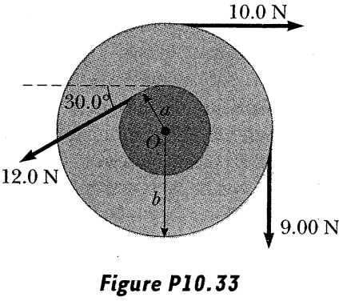6. Torque 1

* The rotational inertia of the wheel shown below is 7.10 N∙m2.   
  The radii of the circles is *a* = 10.0 cm and *b* = 25.0 cm  
  Find (a) the net torque on the wheel and the angular acceleration.

7. Pulley 1

*m*

* The figure to the right shows a uniform disk of mass *M* and radius *R* mounted on a fixed (frictionless) horizontal axle. A block of mass *m* hangs from a light cord that is wrapped around the rim of the disk. Find the acceleration of the falling block, the tension in the cord, and the angular acceleration of the disk.