

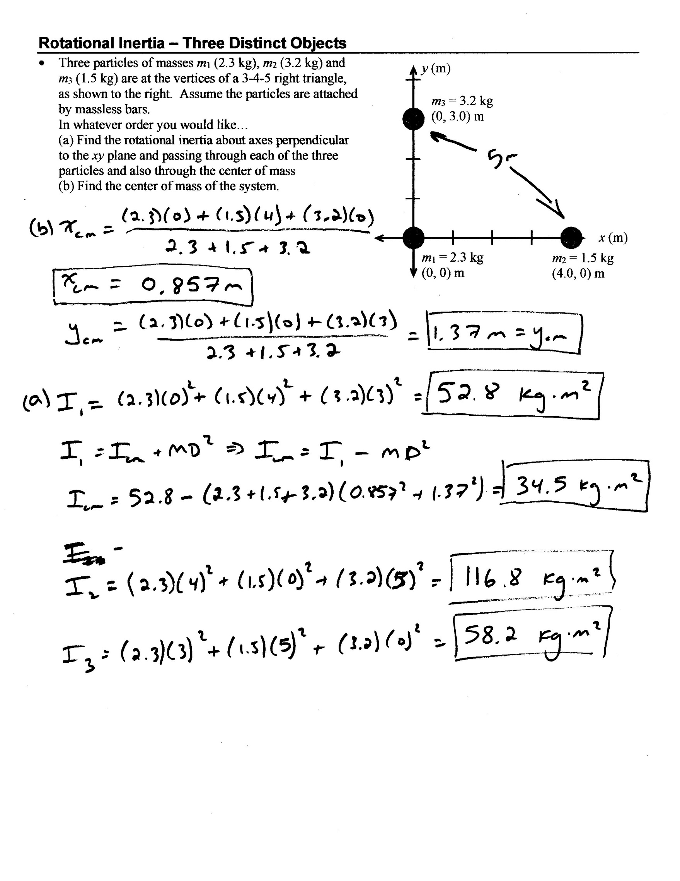





Torque 1

* The rotational inertia of the wheel shown below is 7.10 N∙m2.   
  The radii of the circles is *a* = 10.0 cm and *b* = 25.0 cm  
  Find (a) the net torque on the wheel and the angular acceleration.



