1. A toy rocket of mass 0.50 kg starts from rest on the ground and is launched upward, experiencing a vertical net force. The rocket’s upward acceleration *a* for the first 6 seconds is given by the equation $a=K-Lt^{2}$, where *K* = 9.0 m/s2, *L* = 0.25 m/s4, and *t* is the time in seconds. At *t* = 6.0 s, the fuel is exhausted and the rocket is under the influence of gravity alone. Assume air resistance and the rocket’s change in mass are negligible.
   1. Calculate the magnitude of the net impulse exerted on the rocket from *t* = 0 to *t* = 6.0 s.
   2. Calculate the speed of the rocket at *t* = 6.0 s.
   3. 1. Calculate the kinetic energy of the rocket at *t* = 6.0 s.
      2. Calculate the change in gravitational potential energy of the rocket-Earth system from *t* = 0 to *t* = 6.0 s.
   4. Calculate the maximum height reached by the rocket relative to its launching point.
   5. On the axes below, assuming the upward direction to be positive, sketch a graph of the velocity *v* of the rocket as a function of time *t* from the time the rocket is launched to the time it returns to the ground. *Ttop* represents the time the rocket reaches its maximum height. Explicitly label the maxima with numerical values or algebraic expressions, as appropriate.

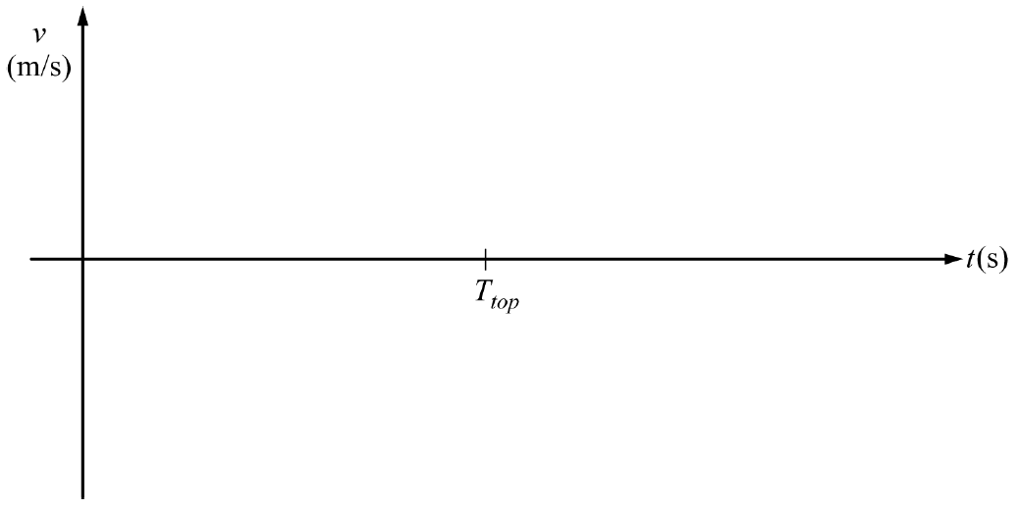

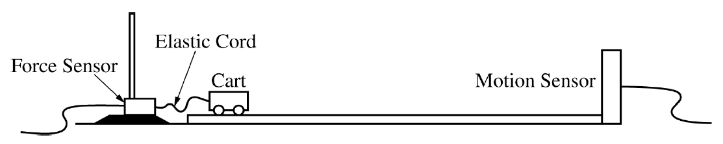

1. A student sets up an experiment with a cart on a level horizontal track. The cart is attached with an elastic cord to a force sensor that is fixed in place on the left end of the track. A motion sensor is at the right end of the track, as shown in the figure above. The cart is given an initial speed of *v*0 = 2.0 m/s and moves with this constant speed until the elastic cord exerts a force on the cart. The motion of the cart is measured with the motion detector, and the force the elastic cord exerts on the cart is measured with the force sensor. Both sensors are set up so that the positive direction is to the left. The data recorded by both sensors are shown in the graphs of velocity as a function of time and force as a function of time below.

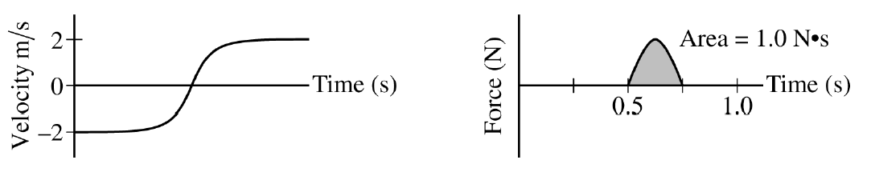

* 1. Calculate the mass *m* of the cart.

For time period from 0.50 s to 0.75 s, the force *F* the elastic cord exerts on the cart is given as a function of time *t* by the equation $F=A\sin\left(ωt\right)$, where *A* = 6.3 N and *ω* = 12.6 rad/s.

* 1. Using the given equation, show that the area under the graph is 1.0 N•s.
  2. The experiment is repeated using a different cord that exerts a larger average force on the cart. The cart starts and ends with the same speeds as those in the original experiment. Will the area for the graph of force as a function of time for the new cord be greater than, less than, or equal to the area for that of the original cord?  
       
     \_\_\_\_\_ Greater than \_\_\_\_\_ Less than \_\_\_\_\_ Equal to  
       
     Justify your answer.

The elastic cord from the original experiment can be modeled as an ideal spring with force constant *k*.

* 1. Derive an expression for the maximum change in length *x*MAX for the cord. Express your answer in terms of *m*, *k*, *v*0, and physical constants, as appropriate.

The student performs several trials of the experiment. For the first trial, the cart is empty. In each succeeding trial, a block is added to the cart. In all trials, the cart has an initial speed of 2.0 m/s to the right, the cart rebounds ot the left with a speed of 2.0 m/s, and the maximum change in length of the elastic cord is measured. The total mass *M* of the cart and the maximum change in length of the cord in each trial are recorded in the table below.

|  |  |  |  |
| --- | --- | --- | --- |
| Total Mass of Cart *M* (kg) | *x*MAX (m) |  |  |
| 0.25 | 0.142 |  |  |
| 0.75 | 0.253 |  |  |
| 1.25 | 0.349 |  |  |
| 1.75 | 0.431 |  |  |
| 2.25 | 0.465 |  |  |

* 1. Indicate below which quantities should be graphed to yield a straight line with a slope that could be used to calculate a numerical value for the force constant of the elastic cord *k*.  
       
     Vertical axis: \_\_\_\_\_\_\_\_\_\_\_\_\_\_\_\_\_\_\_\_  
       
     Horizontal axis: \_\_\_\_\_\_\_\_\_\_\_\_\_\_\_\_\_\_\_\_  
       
     Use the remaining columns in the table on the previous page, as needed, to record any quantities that you indicated that are not given.
  2. Plot the data points for the quantities indicated in part (e) on the graph below. Clearly scale and label all axes, including units as appropriate. Draw a straight line that best represents the data.

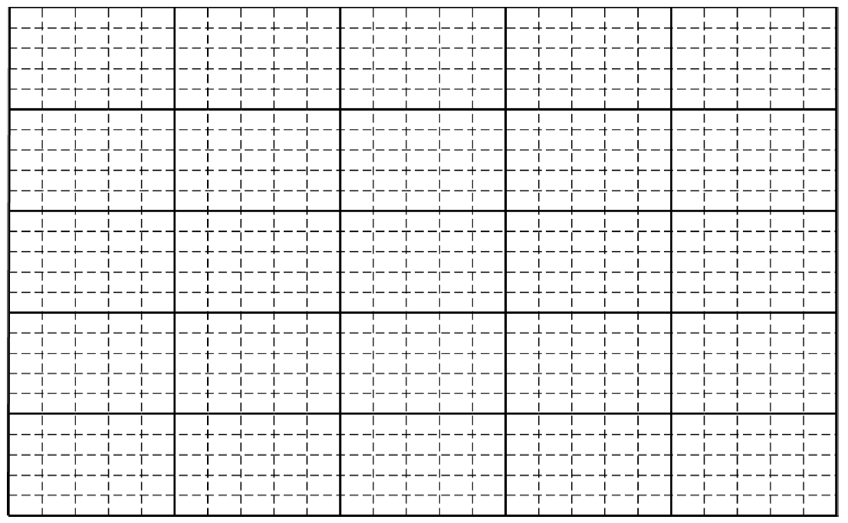

* 1. Use the best-fit line to calculate the force constant *k* of the elastic cord.

C:\Physics\2011-2012\!Misc\ScannedStuff\20120423134405840_0001.tif

1. A projectile is fired horizontally from a launching device, exiting with a speed *vx*. While the projectile is in the launching device, the impulse imparted to it is *Jp*, and the average force on it is *Favg*. Assume the force becomes zero just as the projectile reaches the end of the launching device. Express your answers to parts (a) and (b) in terms of *vx*, *Jp*, *Favg*, and fundamental constants, as appropriate.
   1. Determine an expression for the time required for the projectile to travel the length of the launching device.
   2. Determine an expression for the mass of the projectile.

The projectile is fired horizontally into a block of wood that is clamped to a tabletop so that it cannot move. The projectile travels a distance *d* into the block before it stops. Express all algebraic answers to the following in terms of *d* and the given quantities previously indicated, as appropriate.

* 1. Derive an expression for the work done in stopping the projectile.
  2. Derive an expression for the average force *Fb* exerted on the projectile as it comes to rest in the block.

Now a new projectile and block are used, identical to the first ones, but the block is not clamped to the table. The projectile is again fired into the block of wood and travels a new distance *dn* into the block while the block slides across the table a short distance *D*. Assume the following: the projectile enters the block with speed *vx*, the average force *Fb* between the projectile and the block has the same value as determined in part (d), the average force of friction between the table and the block is *fT* , and the collision is instantaneous so the frictional force is negligible during the collision.

* 1. Derive an expression for *dn* in terms of *d*, *D*, *fT* , and *Fb*, as appropriate.
  2. Derive an expression for *dn* in terms of *d*, the mass *m* of the projectile, and the mass *M* of the block.   
     (For this question set the momentum before the projectile hits the wood block equal to the momentum after it hits.)